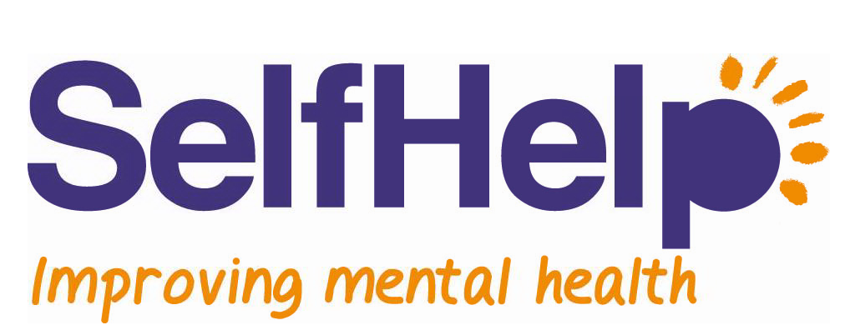

Role Description

Administrative Support (Volunteer)

Based at: Oakland House, Trafford and working-from-home (Covid-19 restrictions dependent)

Purpose

Your role as an Administrative Support Volunteer will be to assist with a variety of administration tasks. Your role will also enhance Big Life’s vision and commitment of reducing health inequalities by providing access to good, up to date and locally focussed health and wellbeing information.

Overview

As part of our Admin Team you will support Talking Therapies Manchester with a variety of essential tasks enabling the smooth running of the service. Specifically, you will be required to input referrals onto our database and discharge clients from our service. You will be working collaboratively with members of our close knit administration team.

Responsibilities

- To ensure that all information inputted into the database is accurate and in accordance with procedure
- To ensure issues of client consent, confidentiality or safeguarding are dealt with appropriately
- To ensure that clients are appropriately discharged from the service according to our policies and procedures
- To issue correspondence (letters, emails, texts etc.) to clients and to GP practices (reports or requests) in an accurate and timely manner
- To contact clients by telephone and ensure their file is updated
- To attend regular supervision and to participate in appropriate team meetings/events
- Undertake any other duties that are needed for the role as they arise
- To undertake any training relevant to the role
- To work in line with Big Life policies and guidelines

Skills and Experience

Essential:
- A willingness and genuine interest in helping others who are struggling with mental health issues and a basic understanding of common mental health problems.
- Excellent IT skills including experience working with Microsoft Office packages.
- Good active listening skills as well as good oral and written communication skills
- A well-organised and methodical approach.
- The ability to work with confidential information while ensuring no wrongful disclosure
- Willingness to learn and embrace new ideas
- Ability to work on own initiative and as part of a team
- Respect for all
- An ability to commit to volunteering for at least 6 months

Desirable:

- Personal “lived experience” of a mental health issue
- Some knowledge of the services offered by Self Help Services and other mental health and social care services in the wider community.
- Previous experience of working with confidential data and databases

What you can expect
- Full training to allow you to develop and carry out your role with confidence (Online and in-person)
- Ongoing support from peers and team leaders
- Monthly supervisions as well as an annual appraisal to support your personal development
- The opportunity to enhance your listening and communication skills
- The opportunity to learn and develop your administrative skills in a mental health setting
- The opportunity to enhance your digital skills on our database and remote systems
- The opportunity to develop your knowledge of mental health services
- The opportunity to work within a supportive team
- A full reference after volunteering with us for 3 months or more
- The opportunity to apply for internal vacancies with the Big Life group
- A full DBS check paid for by Big Life that you can register with the DBS Update Service for free as a volunteer

This is a progressive route which could lead to an employed position within the team

Times and Commitment

4 hours (up to 16 possible) per week, including mandatory training and supervision. We can offer flexibility when organising your schedule, and we would expect you to give as much notice as possible if unable to attend.

Please do contact us if you are at all unsure about these requirements or anything else regarding this role as we will be happy to discuss this in more detail.

