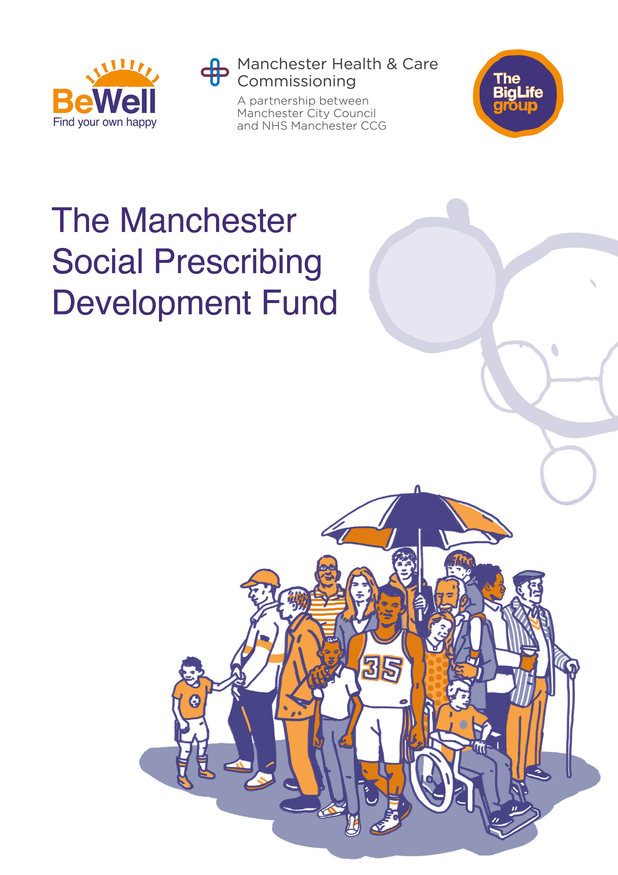

The Manchester Social Prescribing Development Fund
AIM OF THE FUND
The Manchester Social Prescribing Development Fund is funded by Manchester Health and Care Commissioning in partnership with Manchester City Council and is administered by the Big Life group. The fund aims to support new and established groups and organisations to build capacity and deliver projects to support a social prescribing offer to people over the age of 16 and upwards. The fund will support clients in reducing social isolation, improving or help with managing their health and wellbeing.

Applications must demonstrate how they meet one or more of the following aims of the fund:
- Enabling – working with community groups to quickly and easily scale up provision that is overused.
- Responding to opportunities and gaps identified within our communities.
- Connecting – reaching community groups not yet involved in the provision of support to clients of social prescribing services.
- Targeting specific communities or communities of interest.
- Building – adding value and strengthening a local infrastructure.

FUNDING LEVELS
There are 3 levels of grant funding available as shown in the table below. Please ensure you apply for the level of funding that is appropriate for your group or organisation. Applications should demonstrate value for money.

Grant name
Micro Grant | Open to new and existing groups and organisations. | Income must be below £50,000
Medium Grant | Open to new and existing groups or organisations. | Income must be below £200,000
Exceptional Grant  Capped at £20,000 | Must be established over 2 years. | Income must be typically under £500,000.

The Expression of Interest form is mandatory for anyone thinking of applying for the Manchester Social Prescribing Development Funding. We will use the information you provide in the Expression of Interest form to decide whether to invite you to submit a full application. Priority will be given to new and smaller groups.
Please refer to the Manchester Social Prescribing Development Fund Guidance notes on the Big Life Group website, www.thebiglifegroup.com/socialprescribing.
For further information about this fund, please email socialprescribing@thebiglifegroup.com
Manchester Social Prescribing Development Fund 2021/2022  Expression of Interest Form | Date received

SECTION 1 – NAME OF PROJECT
Name of project
Your Name
Job Role

SECTION 2 - APPLICANT DETAILS
Name of organisation
Address of organisation

Contact email and telephone number
Date organisation established and company/charity number
Details of annual income | 2020/21 |  | 2019/20

SECTON 3 – ABOUT YOUR ORGANISATION

SECTION 4 - HOW DID YOU HEAR ABOUT THIS FUNDING?

SECTION 5 - HOW DID YOU COME UP WITH THE IDEA – WHO WAS INVOLVED?

SECTION 6 – ABOUT THE PROJECT

Please provide details of the proposed project and the benefits that this project will bring for participants, organisation, group, or wider community.

Please describe how the proposed activity will link in with and support clients of the Be Well service.

Please also confirm which of the 5 aims of the fund you will address (please refer to the background and guidance document at www.thebiglifegroup.com/socialprescribing

All activity must be Covid-19 risk assessed and undertaken in line with government guidance. (Maximum 750 words)

SECTION 7 – WHERE WILL YOUR ACTIVITY TAKE PLACE?

SECTION 8 – HOW MANY BE WELL CLIENTS WILL YOU SUPPORT?
(please also state how long the project will run).

Is this a new project? |  | If existing, what will you use the funding for?

SECTION 5 – PROJECT FINANCES
a) Cost of project
b) Amount of grant required

Signed

Print Name

Position in Company

Date

Please send your completed application form to:
socialprescribing@thebiglifegroup.com

